CONFIDENTIAL TO: The Governor, Central Bank of Kenya
FROM: Stephen Munene (Policy Analysis Unit)
DATE: March 21, 2026
SUBJECT: Retrospective Analysis of Inflation Volatility (1960–2024): A Statistical Risk Audit

1. Executive Summary
This memorandum provides a quantitative "health check" of Kenya's price stability over the last 65 years. By applying a Z-score framework—a method of measuring how "abnormal" a year is relative to history—we have identified the structural DNA of Kenyan inflation.
Our findings indicate that while the CBK has successfully anchored inflation in recent years, the historical "DNA" of the Shilling is characterized by high volatility and a tendency for sudden, extreme upward shocks (Right-Skewness).

2. The "DNA" of Kenyan Inflation
To understand where we are going, we must define our historical baseline.
- The Anchor (Mean): Since 1960, Kenya’s average annual inflation has been 9.7%.
- The Volatility (Standard Deviation): Our "swing factor" is 7.98%. In practical terms, this means that in any given year, it is "statistically normal" for inflation to fluctuate wildly between 1.7% and 17.7%.
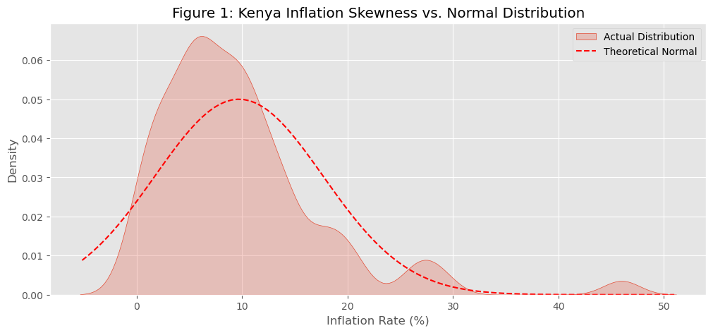
3. Identification of "Black Swan" Events (Risk Audit)
We utilized Z-scores to flag years that were mathematically "Extreme." A Z-score of +2.0 or higher represents a crisis that occurs less than 5% of the time.
- The 1993 Hyper-Shock (Z = 4.54): This remains the greatest outlier in our recorded history. With inflation at 45.9%, this was a "4-Sigma" event—statistically, something that should almost never happen. It serves as a reminder of the risks of rapid money supply expansion.
- The 2008 Supply Shock (Z = 2.07): The post-election crisis and global oil spike pushed us into the "High Risk" zone, proving how external shocks can break our internal stability.
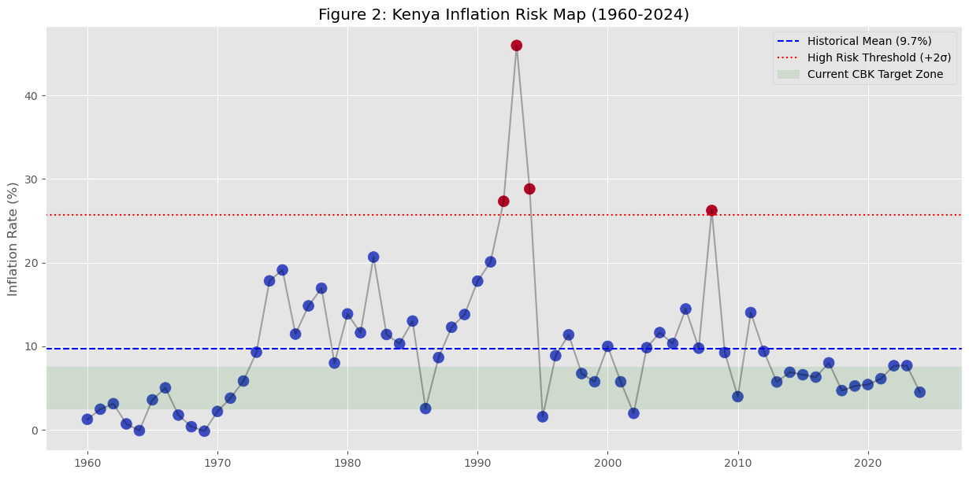

4. Policy Implications & Realism
The current CBK target of 5.0% ± 2.5% is an ambitious departure from our 65-year history.
- The "Efficiency" Gap: Our current target (max 7.5%) is significantly lower than our historical average (9.7%). This confirms that the modern CBK is far more "hawkish" and disciplined than the administrations of the 70s and 90s.
- Buffer Requirements: Because our volatility (σ) is high, the Bank must maintain robust foreign exchange reserves to defend the Shilling against the "Right-Tail" risks identified in this report.

5. Conclusion
Kenya’s inflation is not a "Normal Distribution." It is a "Shock-Prone Distribution." While the last decade shows a tightening of control, the ghost of the 1993 Z-score (4.54) suggests that price stability is a fragile equilibrium that requires constant, data-driven vigilance.
Recommendation: The MPC should continue to treat any Z-score move toward +1.5 as an immediate signal for intervention before it cascades into a "2-Sigma" crisis.

Stephen Munene,
Lead Data Scientist.
PROJECT DISCLAIMER: ACADEMIC SIMULATION
This project is a purely academic simulation and is part of a personal data science study. The author, Stephen Munene, is not an employee, contractor, or representative of the Central Bank of Kenya (CBK). All titles used (e.g., "Policy Analyst," "Lead Data Scientist") are for the purpose of role-playing a technical task. The "Confidential" branding is used for atmospheric realism in a mock-business setting. Do not treat this as official government data.

